AI Error and explanation:

**Error: 1**

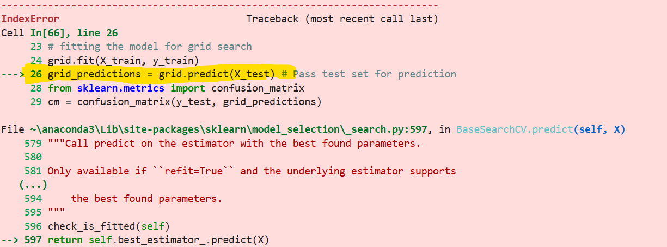



**Solution:**

**You need to pass independent and dependent values**,there is no need to pass X_train and Y_train after categorical conversion. This is because during the conversion from categorical to numeric data, some categories are present in the training set but not in the test set.